INSTALLATION OF PYTHON FOR WINDOWS

Download the latest version of python from the following link

<https://www.python.org/downloads/>

Currently the latest version of python is 3.6.

1. Run the python.exe file and follow installation steps.
2. This is the python editor

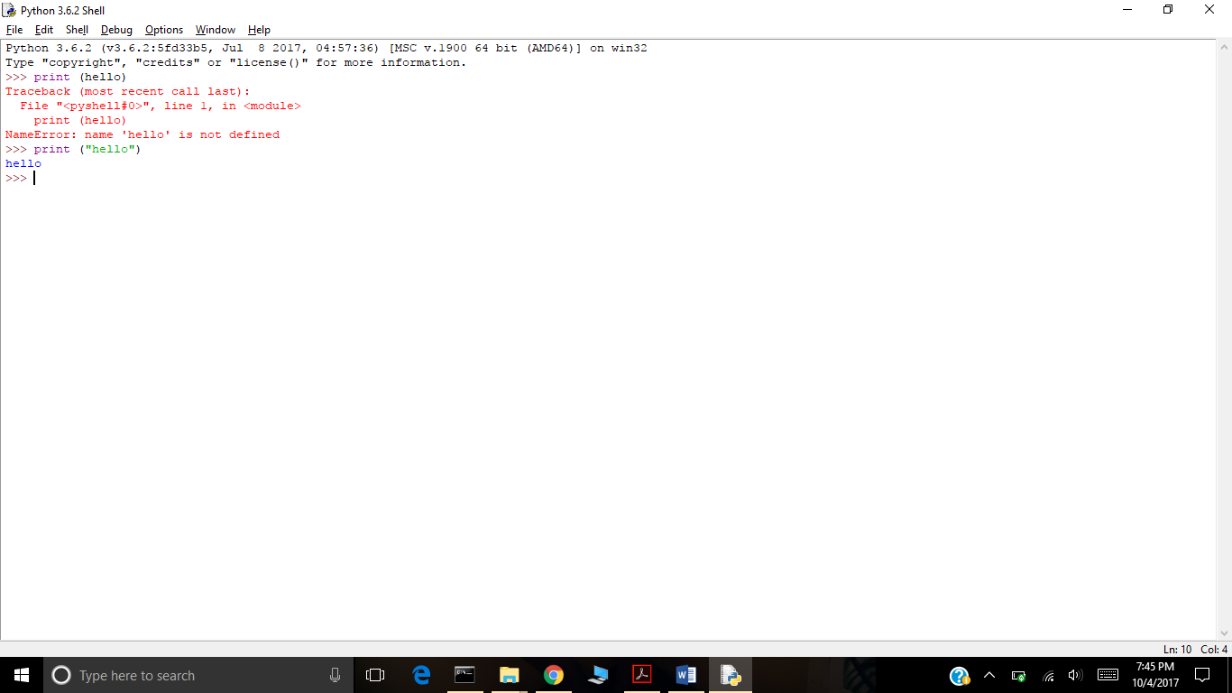

After successful installation open command prompt and navigate to the folder which has pythin installed and type python to verify the installation

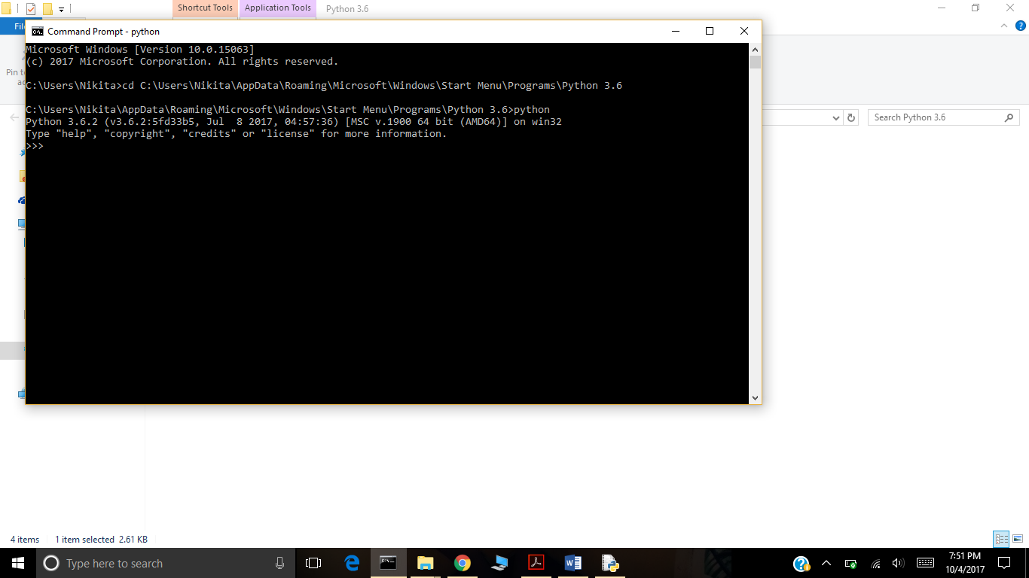

The >>> shows that python editor has stared and with it shows the version.

Navigating to the python folder and then running the python is not feasible.Therefore,we can set python path in the environement variable which allows us to run python from any location.

We can set this in the environment variables for Windows

* In the system variables add %PYTHON_HOME%\;%PYTHON_HOME%\Scripts\ to the PATH variable.

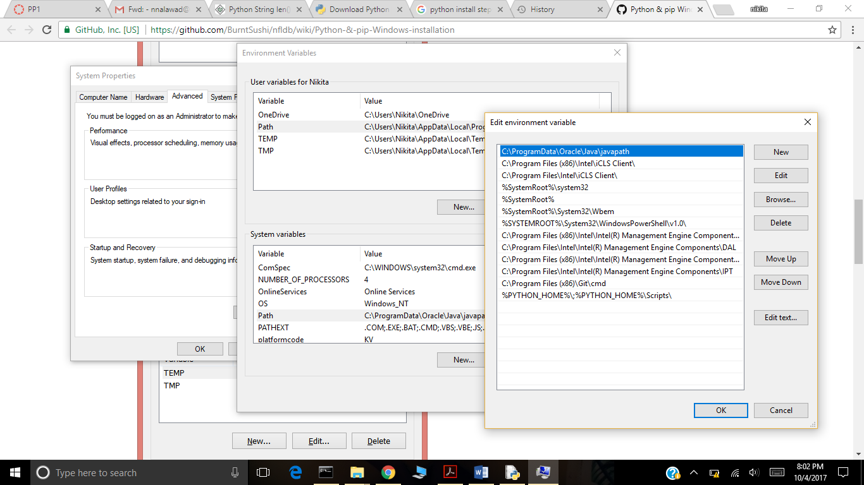

* Add the path to python folder in PYTHON_HOME variable which in our case is

C:\Users\Nikita\AppData\Roaming\Microsoft\Windows\Start Menu\Programs\Python 3.6

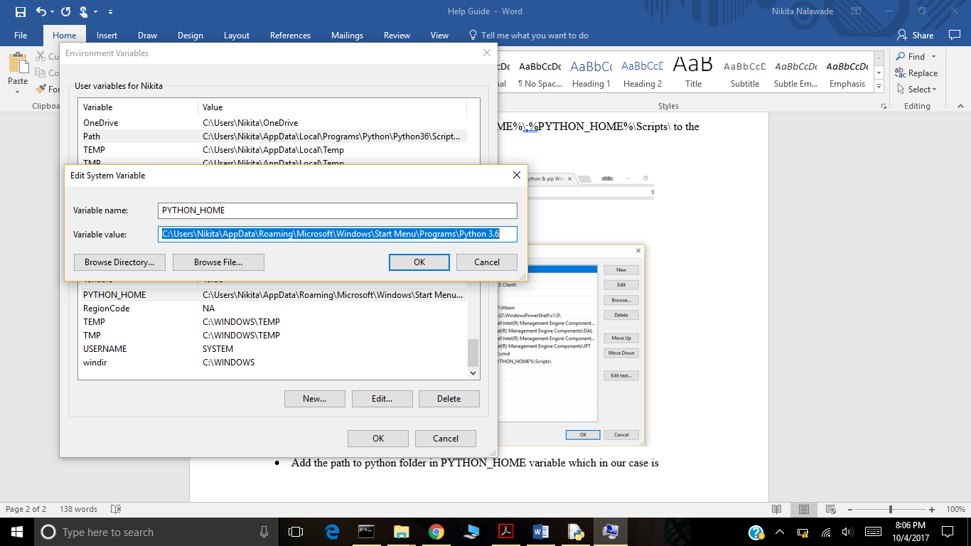

PIP INSTALLATION.

For python 3 and above version PIP is already installed with python installations.

We only need to import it.

In the command prompt we can write this command

>>> import pip

Similarly, we can install other packages.

When pip is imported we can verify it, by typing the command “pip freeze” in the location where python is installed.